6th Annual
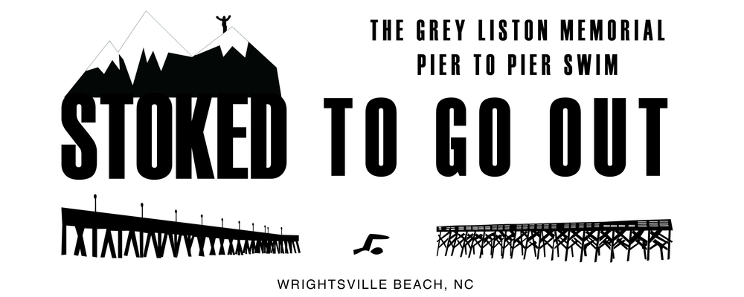
Open Water Swim Saturday, May 18th 2019

Wrightsville Beach, North Carolina. Support swimming & diving student athletes at the University of North Carolina Wilmington and celebrating Grey Liston. The 6th annual Grey Liston memorial ocean swim is 1.7 miles between Johnnie Mercer's Pier and Crystal Pier. It’s a length of Atlantic Grey swam many times UNC-Wilmington Seahawk swimmer and a guard on Wrightsville Beach Ocean Rescue. Proceeds benefit the UNCW "GREY LISTON SCHOLARSHIP IN ATHLETICS ENDOWMENT".

REGISTER & RACE DETAILS: StokedToGoOut.com
COST is $40 + $3.00 sign-up fee.
REGISTRATION FEE MAY INCREASE NEAR RACE DAY.

AWARDS in the following categories:

Overall Male, Overall Female, Top 3 in the following categories: 11-14, 15-18, 19-24, 25-29, 30-34, 35-39, 40-44, 45-49, 50-54, 55-59, 60-64, 65-69, 70+

Stay stoked! StokedToGoOut.com

